Nombre:_____________________________________ Fecha:___________________
Español 7 - Mi familia – Family Photo Album

Your family is pretty awesome and you decided to make your a photo album all about them! You will do this entirely in Spanish, and it will describe 7 people in your family. This can be about your real family, or you can use pictures printed off the internet/magazines to make up your family. In order to use all of the vocabulary that we have been learning, please only do human beings! This is worth a quiz grade so make sure you use your book for spelling and double check your work!

The following guidelines will help you with your photo album. Ask yourself these questions to make sure you are on the right track…
- _____Does your album include 7 human beings?
- _____ Did you include yourself as one of the family members?
- _____Does each person have a picture? _____And does each picture have a paragraph about the person underneath it?
- _____Did you correctly spell the words and use appropriate vocabulary? _____Did you use a wide variety of vocabulary?
- _____Did you include all of the necessary information about the person in the paragraph under their name?
- _____Is it colorful, neat, pretty, organized, and well done with an excellent amount of effort?

Here is the basic format for each picture in your album…
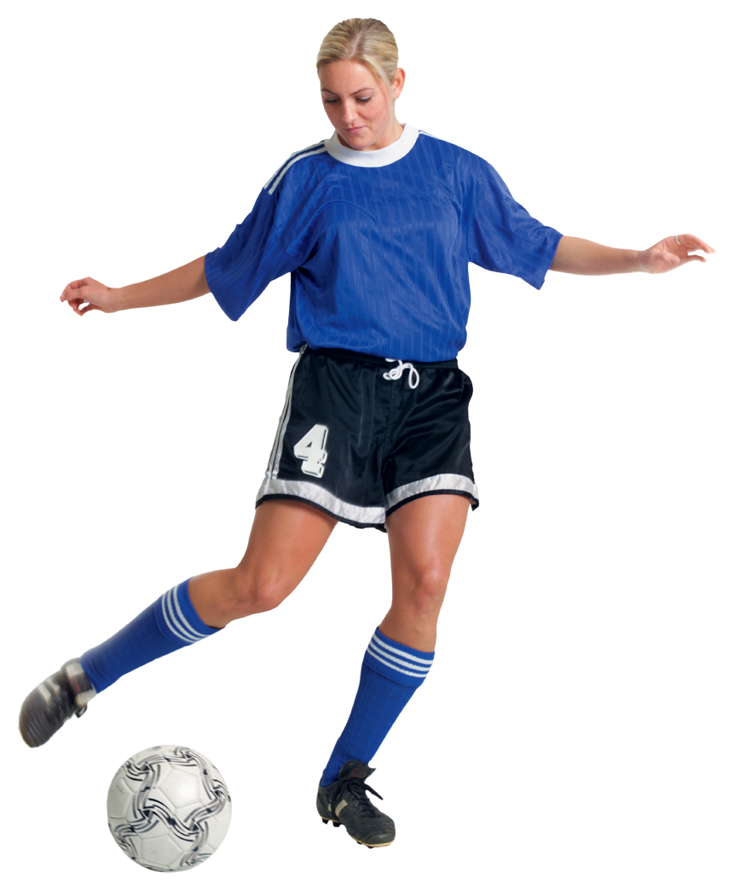
Ésta es mi hermana. Ella se llama Haley. Su cumpleaños es el 14 de marzo. Ella tiene 12 años. Ella es atlética, un poco bonita y bastante alta. Ella no es perezosa, tímida o graciosa.

Include a picture, with a paragraph including an:
introduction, name, birthday, age, 3 adjectives describing what they are, and 3 adjectives describing what they are not.

This should look like a photo album, so it needs to be bound either by staples, or string. It needs to have a cover with a title:
Mi Familia Por: María Castaldo (My Family By: Maria Castaldo)
Use the back sheet for reference, and hand this in with your project. I will use this to grade your project!

Buena suerte
Nombre:____________________________________________ Per:______________________

RUBRIC

PERSONA #1
_____ introduction
_____ name
_____ birthday
_____ age
_____ 3 positive adjectives that the person is
_____ 3 things that the person is not
_____TOTAL / 12 PTS
PERSONA #2
_____ introduction
_____ name
_____ birthday
_____ age
_____ 3 positive adjectives that the person is
_____ 3 things that the person is not
_____TOTAL / 12 PTS

PERSONA #3
_____ introduction
_____ name
_____ birthday
_____ age
_____ 3 positive adjectives that the person is
_____ 3 things that the person is not
_____TOTAL / 12 PTS
PERSONA #4
_____ introduction
_____ name
_____ birthday
_____ age
_____ 3 positive adjectives that the person is
_____ 3 things that the person is not
_____TOTAL / 12 PTS
PERSONA #5
_____ introduction
_____ name
_____ birthday
_____ age
_____ 3 positive adjectives that the person is
_____ 3 things that the person is not
_____TOTAL / 12 PTS

PERSONA #6
_____ introduction
_____ name
_____ birthday
_____ age
_____ 3 positive adjectives that the person is
_____ 3 things that the person is not
_____TOTAL / 12 PTS

PERSONA #7
_____ introduction
_____ name
_____ birthday
_____ age
_____ 3 positive adjectives that the person is
_____ 3 things that the person is not
_____TOTAL / 12 PTS

COVERPAGE W/ TITLE & NAME (6 PTS)
EFFORT (10 PTS)

TOTAL / 100 PTS =

Nombre:_______________________________________
Photo Album Quiz Grade – Project Outline
La persona # 1 _____________________________
Introduction: __________________________________________________________________________
Name: __________________________________________________________________________
Birthday: __________________________________________________________________________
Age: __________________________________________________________________________
3 + adjectives: __________________________________________________________________________
______________________________________________________________________________________
3- adjectives: __________________________________________________________________________
_____________________________________________________________________________________
La persona # 2 _____________________________
Introduction: __________________________________________________________________________
Name: __________________________________________________________________________
Birthday: __________________________________________________________________________
Age: __________________________________________________________________________
3 + adjectives: __________________________________________________________________________
______________________________________________________________________________________
3- adjectives: __________________________________________________________________________
_____________________________________________________________________________________
La persona # 3 _____________________________
Introduction: __________________________________________________________________________
Name: __________________________________________________________________________
Birthday: __________________________________________________________________________
Age: __________________________________________________________________________
3 + adjectives: __________________________________________________________________________
______________________________________________________________________________________
3- adjectives: __________________________________________________________________________
_____________________________________________________________________________________
La persona # 4 _____________________________
Introduction: __________________________________________________________________________
Name: __________________________________________________________________________
Birthday: __________________________________________________________________________
Age: __________________________________________________________________________
3 + adjectives: __________________________________________________________________________
______________________________________________________________________________________
3- adjectives: __________________________________________________________________________
_____________________________________________________________________________________
La persona # 5 _____________________________
Introduction: __________________________________________________________________________
Name: __________________________________________________________________________
Birthday: __________________________________________________________________________
Age: __________________________________________________________________________
3 + adjectives: __________________________________________________________________________
______________________________________________________________________________________
3- adjectives: __________________________________________________________________________
_____________________________________________________________________________________
La persona # 6 _____________________________
Introduction: __________________________________________________________________________
Name: __________________________________________________________________________
Birthday: __________________________________________________________________________
Age: __________________________________________________________________________
3 + adjectives: __________________________________________________________________________
______________________________________________________________________________________
3- adjectives: __________________________________________________________________________
_____________________________________________________________________________________
La persona # 7 _____________________________
Introduction: __________________________________________________________________________
Name: __________________________________________________________________________
Birthday: __________________________________________________________________________
Age: __________________________________________________________________________
3 + adjectives: __________________________________________________________________________
______________________________________________________________________________________
3- adjectives: __________________________________________________________________________
_____________________________________________________________________________________

PEER EDITOR SIGNATURE #1 - ______________________________________

PEER EDITOR SIGNATURE #2 - ______________________________________

PEER EDITOR SIGNATURE #3 - ______________________________________

