**C:\Users\antoniol\AppData\Local\Microsoft\Windows\Temporary Internet Files\Content.IE5\XLQO7WNU\MC900183538[1].wmfWhat do you know about Mexico?**

|  |
| --- |
| **Places of Interest:**   * Identify the capital * Identify and describe two places of interest (besides the capital) |
| **El Arte:**   * Identify two important Mexican artists |
| **Celebrations/Foods:**   * Identify and describe one important celebration other than Day of the Dead * Identify major aspects of the Day of the Dead * Identify and describe three typical Mexican specialties |

C:\Users\antoniol\AppData\Local\Microsoft\Windows\Temporary Internet Files\Content.IE5\R3WIKZUL\MC900030401[1].wmf 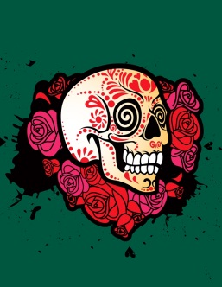 C:\Users\antoniol\AppData\Local\Microsoft\Windows\Temporary Internet Files\Content.IE5\37W3EQD6\MC900341028[1].wmf [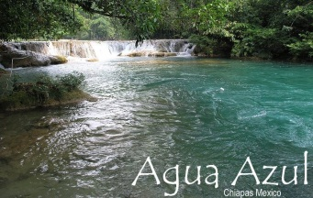](http://www.google.com/url?sa=i&rct=j&q=agua+azul&source=images&cd=&cad=rja&docid=WukTi28k3hn5XM&tbnid=elU17MtW3_VaGM:&ved=0CAUQjRw&url=http://www.locogringo.com/chiapas/aguaazul.html&ei=TH2aUe3XH-644APR14G4Bw&bvm=bv.46751780,d.dmg&psig=AFQjCNFGwhdCIiVSkKoMgF1eVlo7zne68A&ust=1369165506609863)