Nombre:_________________________________________________ Fecha:________________________

¡Mi árbol genealógico!
Family Tree Poster Project

We have been talking a lot about our families, and we now know many different ways to talk about people. For this poster project, you will make a family tree in Spanish of your family. If you would rather invent a family rather than talk about your own, that’s ok too! This will be worth a quiz grade, so make sure you are using your book and vocabulary sheets!

Here is what you need to include…
- A title: Mi familia/Mi árbol genealógico ideal/La familia Nummelin
- A family tree that has at least 10 family members, this can include your pets.
- You must include yourself, and label it “YO”
- Each person/pet must have a picture and a description.
  - Under each picture, the description must include at least 4-6 sentences about what the person looks like, their personality, and their likes/dislikes. **FOCUS ON THE 5.1 VOCAB!
- Colorful, neat, and attention to detail.
- Correct spelling/grammar: NO excuses! This is an open book quiz grade!

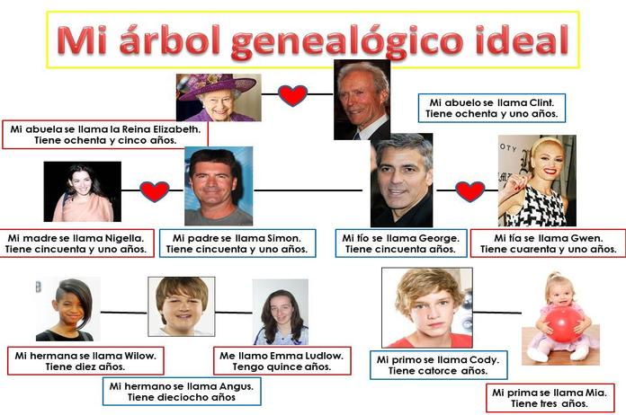
¡Buena suerte! This will be started in class as a rough draft, and will be finished at home. Please stay after school for extra help and ask questions in class
El ÁRBOL GENEOLÓGICO: EXAMENCITO

Here is your rubric and exactly what you will be graded on. Pass this paper in with your project!
***When you think you are finished, ask yourself, “Have I included all of the required sections, and is it well-done with my greatest amount of effort?”

CATEGORY | 4 | 3 | 2 | 1
Title, name, class period, date. | Excellent  All necessary information included. | Fair  Missing one item. | Needs improvement  Missing 2-3 items. | Unacceptable  Missing more then 3 items.
At least 10 family members with labels. | Excellent  Includes all 10 members with labels. | Fair  Missing 1 family member with labels. | Needs improvement  Missing 2-3 family members. | Unacceptable  Missing more than 4 family members.
Each family member has a well-done paragraph. | Excellent amount of information for each member. (4-6 sentences) | Fair  amount of information for each member. | Needs improvement Minimal effort for the paragraph. | Unacceptable effort. Messy, spelling errors, not using current voc.
Spelling/Grammar | Excellent  No more than two or three errors. | Fair  There are no more than 4 errors. | Needs improvement  There are several errors. | Unacceptable  Careless amount of errors.
Colorful/Neat/Effort | Excellent  Poster is very neat, colorful, well organized, and easy to read. | Fair  Poster is somewhat colorful and neat, but could use more effort. | Needs improvement  Poster lacks effort appropriate amount of effort, & is unorganized. | Unacceptable  Lack of effort and attention to detail.

_____________ -10 each day late

PUNTOS/20 ____________ =
Comentarios:

